Chapter 14, Problem 87.

In the interval 0.1 < f < 100 Hz, plot the response of the network in Fig. 14.104. Classify this filter and obtain ω₀.

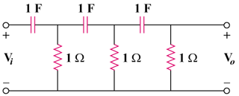

Figure 14.104
For Prob. 14.87.

